**Task 3**

1.Create an AWS EC2 instance

2.Configure the instance with Apache Webserver.

3.Download php application name "WordPress"".

4.As wordpress stores data at the backend in MySQL

5.Database server. Therefore, you need to setup a MySQL server using AWS RDS service using Free Tier.

6.Provide the endpoint/connection string to the

WordPress application to make it work.

Now i am going to share some of the images of my task .

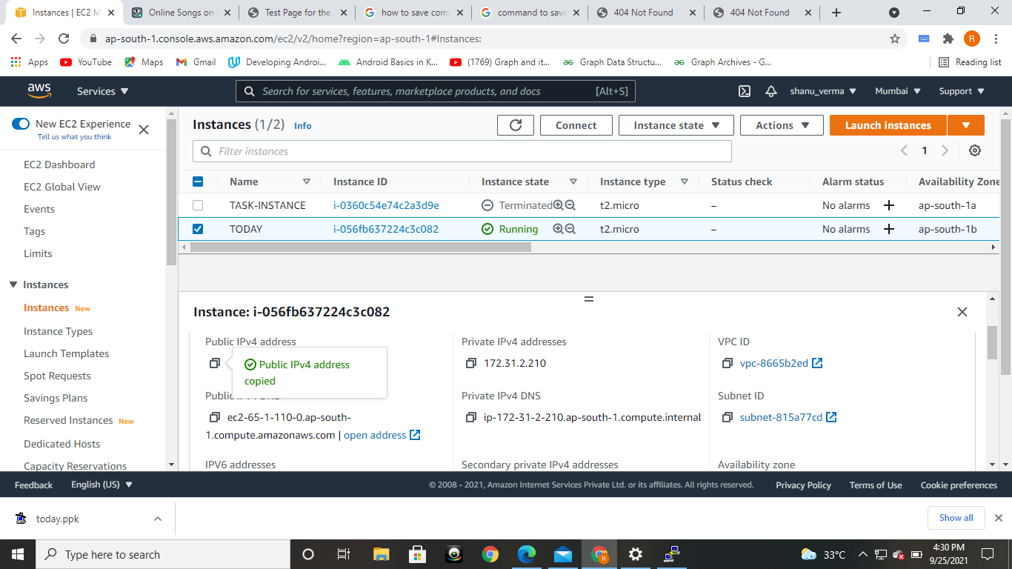

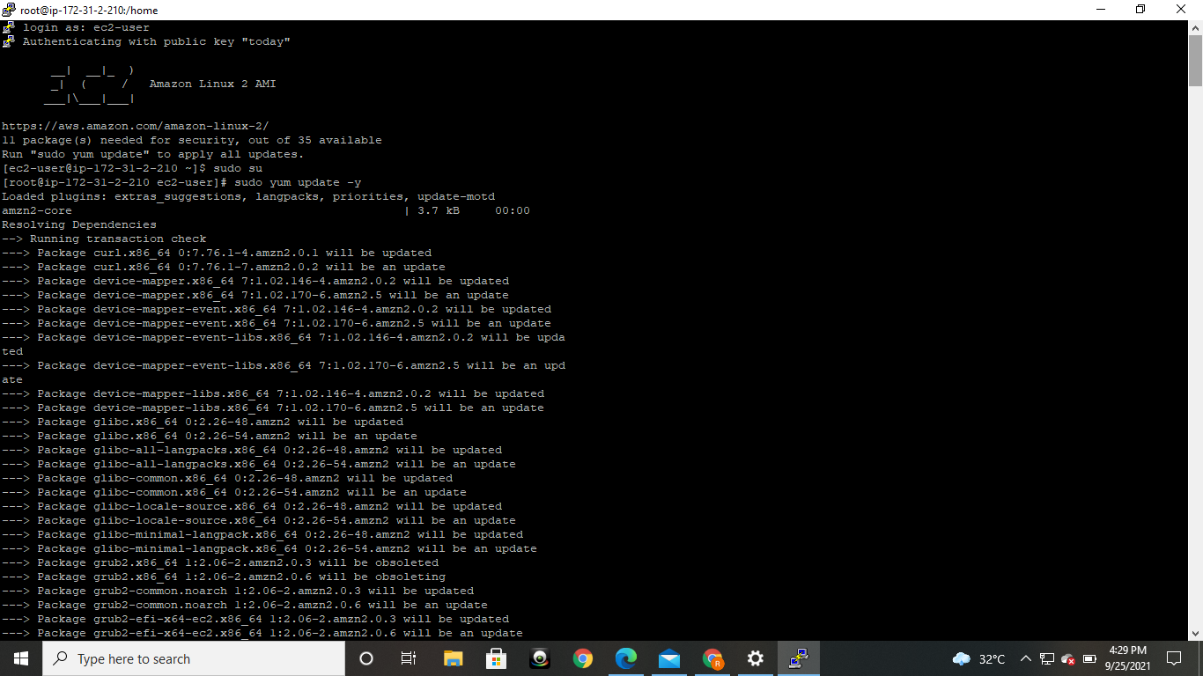

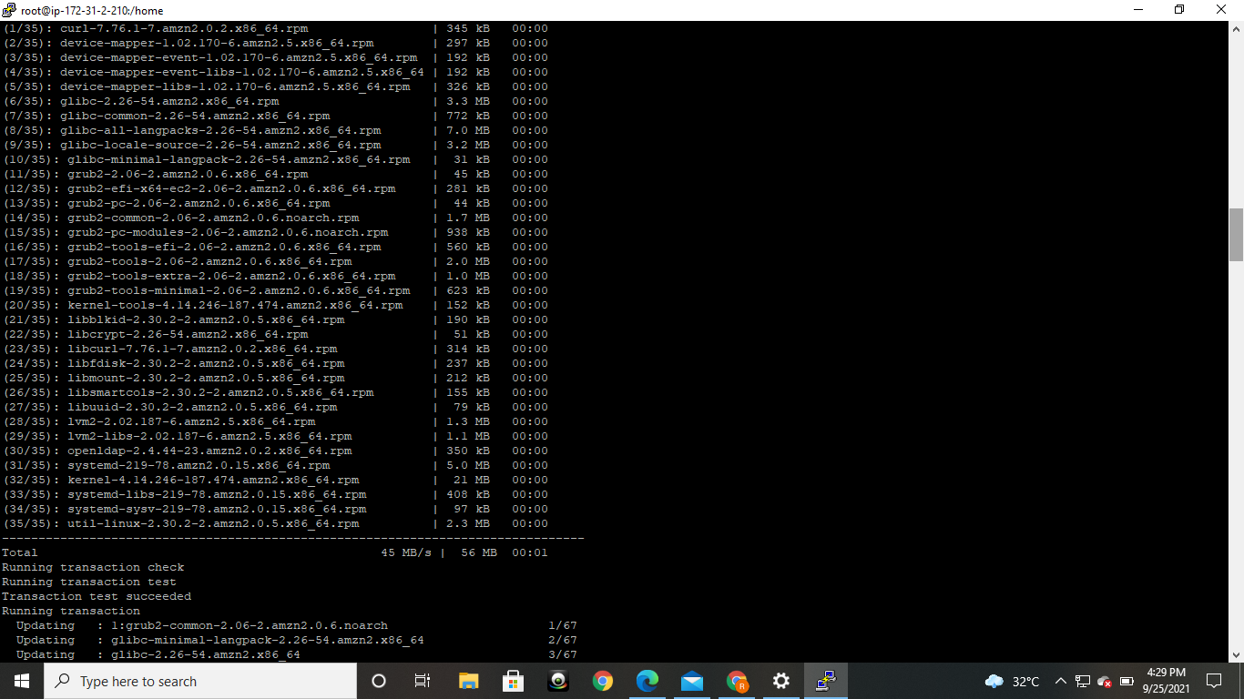

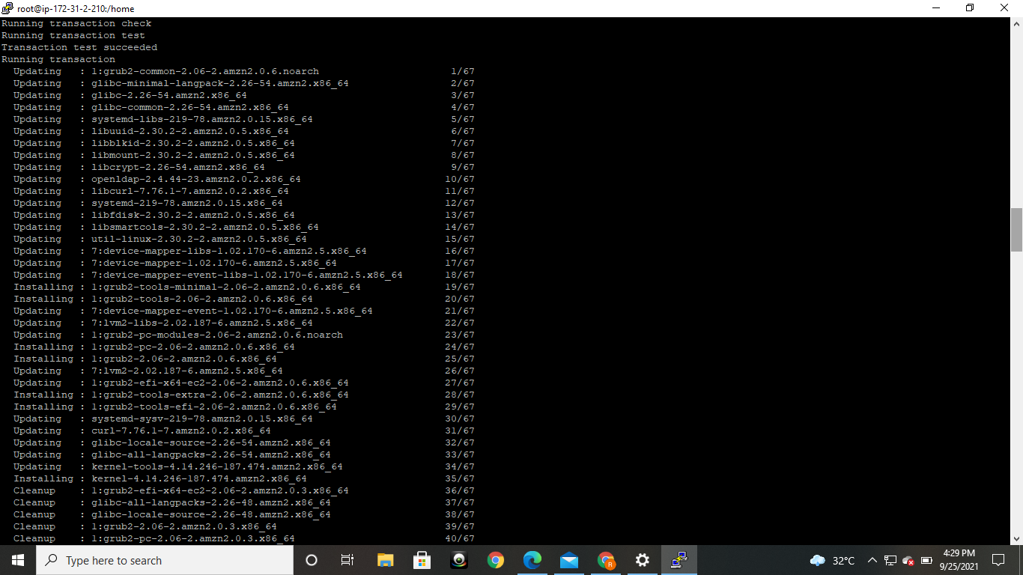

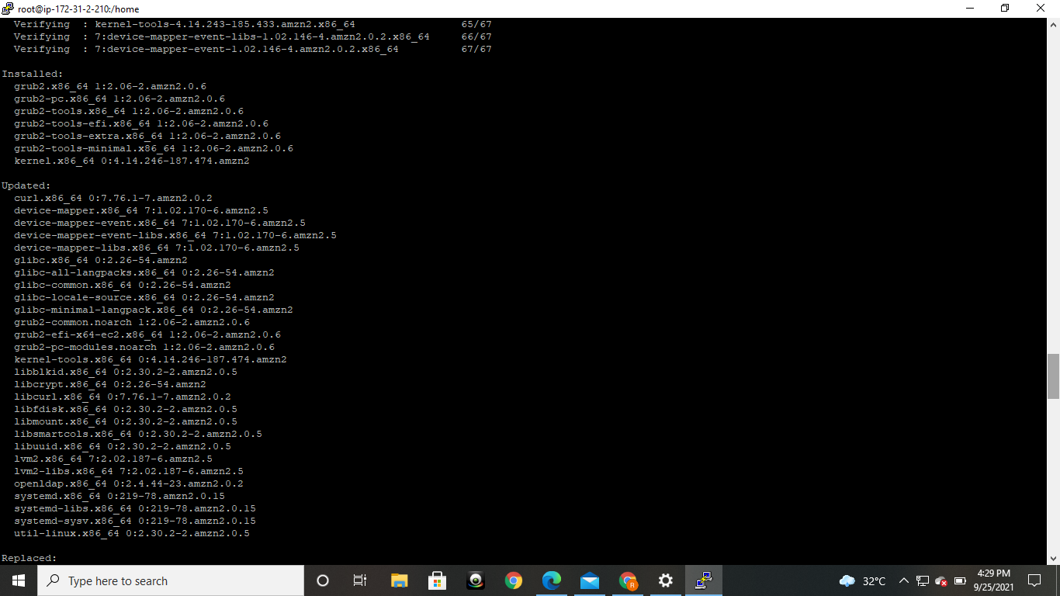

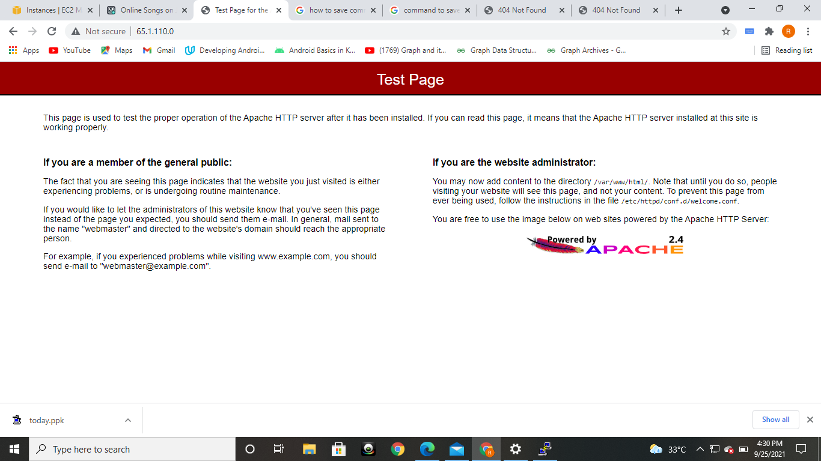

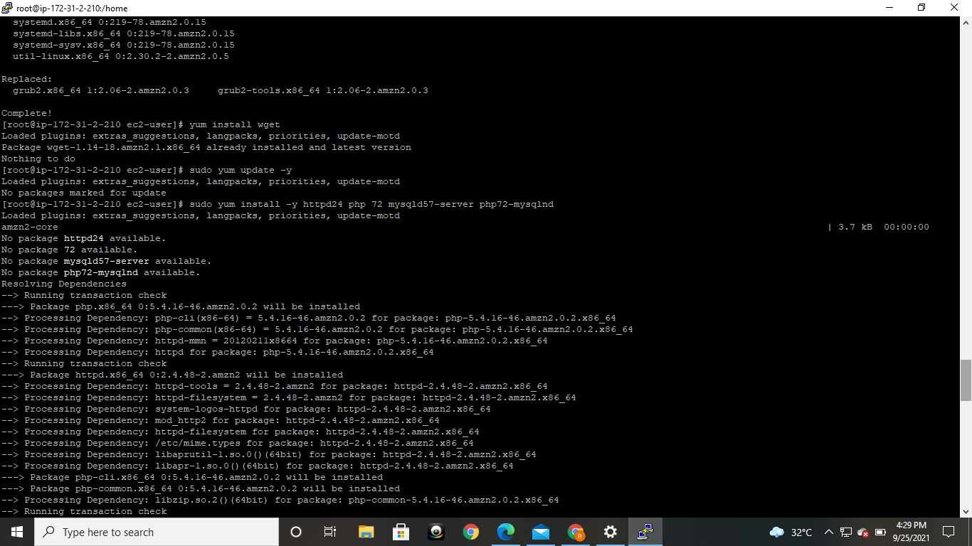

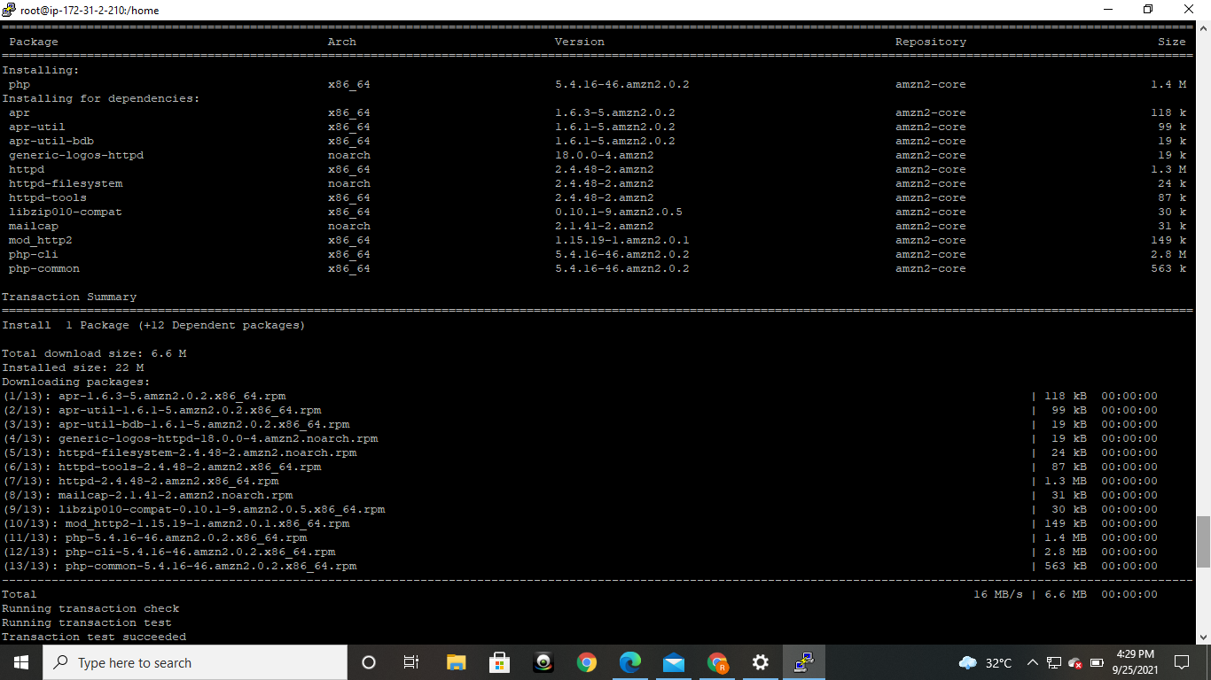

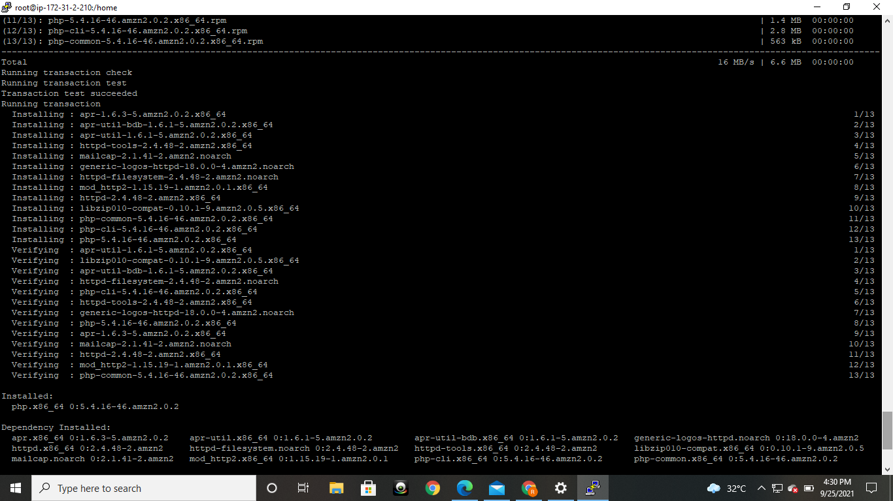

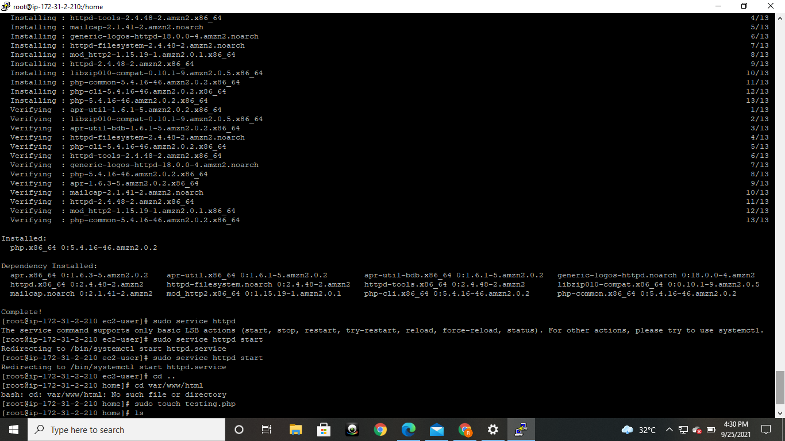

THANK YOU